This documents purpose is the configuration of MS SQL Server’s Reporting Services after they have been installed. For direction on installing Reporting Services please refer to the SQL Server Installation guide.

The configuration is performed using the ‘Reporting Services Configuration Manager’, it is installed in the Configurations for MS SQL Server at the time Reporting Services were installed.

The initial screen is very similar to the connection screen of MS SQL Server.

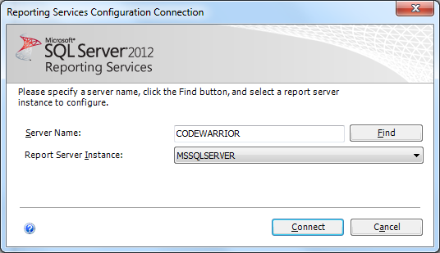

Verify the correct Server Name is listed along with the proper Report Server Instance. If the installation steps defined in the Installing SQL Server section of this document, the defaults should reflect that specific server and instance.

If everything is correct you can click the “Connect” button. The Reporting services Configuration Manager will launch and the Report Server Status should be displayed. From this screen you can control the Reporting Services service, if changes are made to the configuration it is required to Stop and Restart the service, this screen offers that functionality.

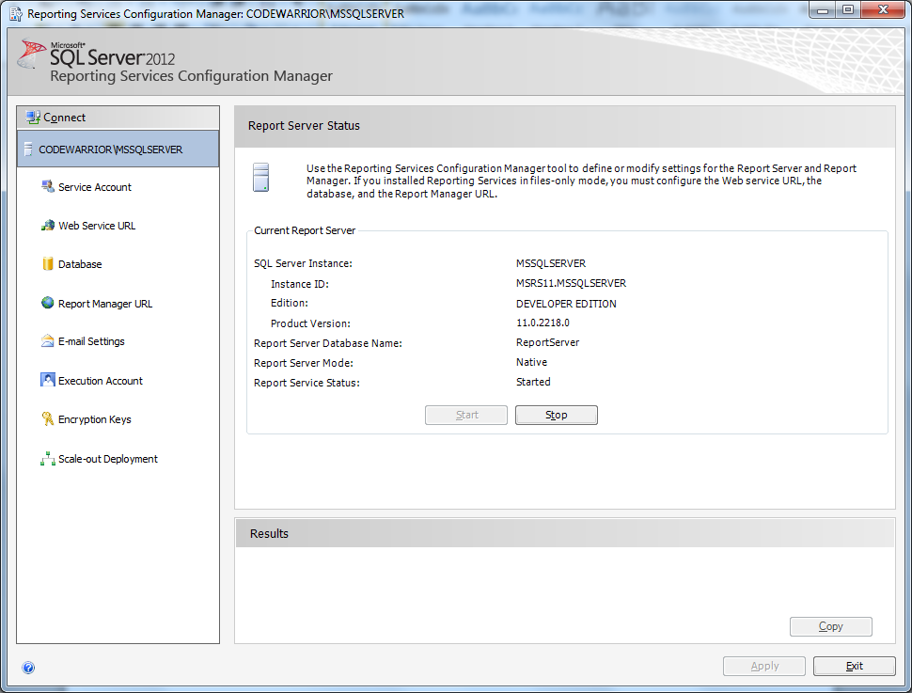

On the left hand side of the screen there are tasks that we need to verify or configure. Ost of these will already be set if the SQL Server Installation guide was followed.

Click the Service Account task and the Service Account screen will be displayed.

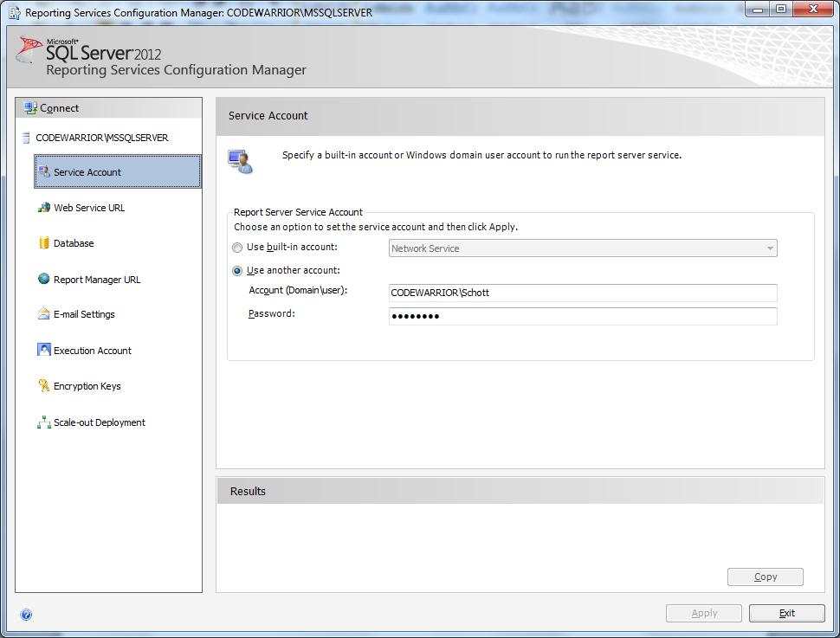

On this screen you have the ability to select which users account to use for execution. It is recommended that you use the same account as MS SQL Server is using .

Click the Web Service URL task, the Web Service URL screen will be displayed.

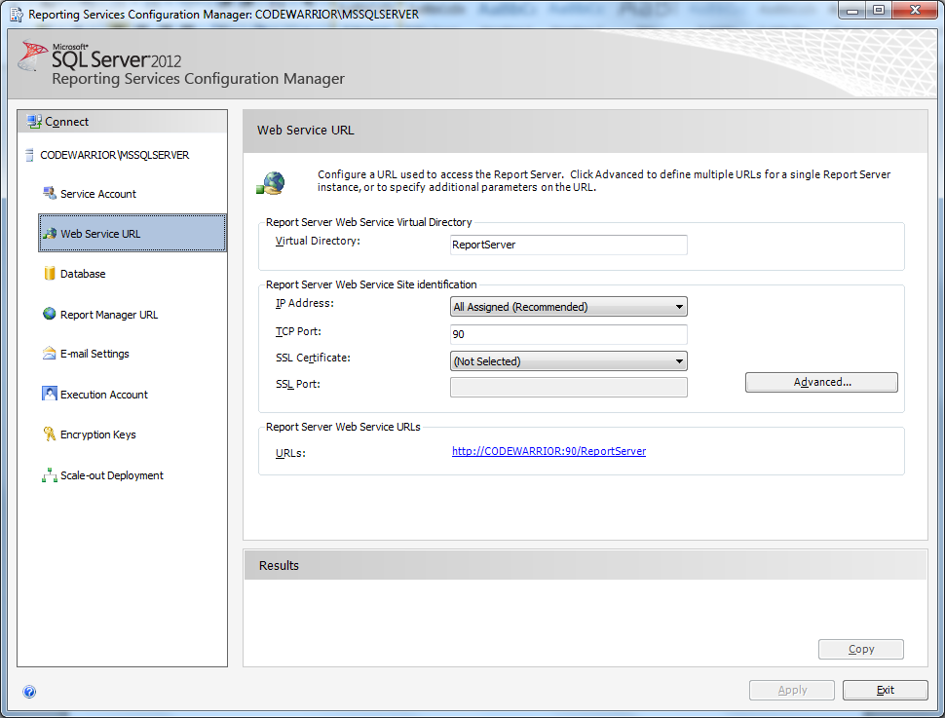

From this screen you may set the virtual Directory, IP Address, Port, SSL Certificate, SSL Port. Our recommendations are as follows.

**Virtual Directory**: The default name of ReportServer is fine, however if you choose to rename it to something else, it is strongly recommended against using any spaces in the name. If for readability spaces are desired, use the underscore character for the space.

**IP Address:** It is recommended to use the All Assigned option for this

**TCP Port:** It is strongly recommended this port be something other than 80 when Reporting Services are installed on the same box as a Web Server.

**SSL Certificate:** If you need to bind the ReportServer to a SSL Certificate, it is required for you to install the certificate to the users certificate store in which the Reporting Services service is executing under before attempting to bind it here.

**SSL Port:** It is recommended the SSL port be different from the TCP Port.

If you need multiple HTTP or multiple SSL identities you should click the advanced button at this time. This will bring you to the Advanced Multiple Web Site Configuration screen.

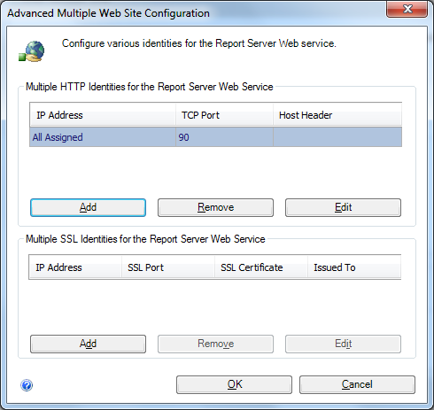

All the information that was entered on the previous screen (Web Service URL) will be carried over to this screen. In each group box you are able to add the additional identities. When you are complete, click OK to save the changes, or Cancel to discard the changes.

To test the settings, click the links in the Report Server Web Service URL’s group box. There should be a separate URL for each HTTP and SSL identity.

Click the Database task and the Report Server Database screen will be displayed.

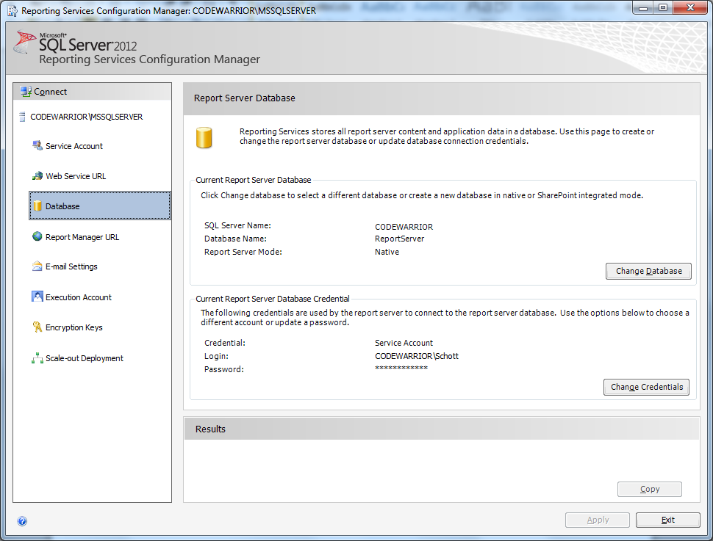

From this screen you can change the SQL Server and database that is servicing this instance of Reporting Services, there should be no need to do this on a fresh install or if the installation directions for SQL Server provided were followed. If there is a need you would click the Change Database button a wizard will be displayed to walk you through it. I needs to be noted that all report definitions will not be available until they are uploaded to the new SQL Server / Database. The data sources for each report definition will also need to be modified if the data driving the reports are being moved as well.

From this screen you are also able to modify the credentials for accessing the Report Server’s Database; it is recommended this account be the same as the Reporting services service is executing under. This option is available here primarily for the case of where the report servers database is relocated to a different server.

Click the Report Manager URL task and the Report Manager URL screen will be displayed.

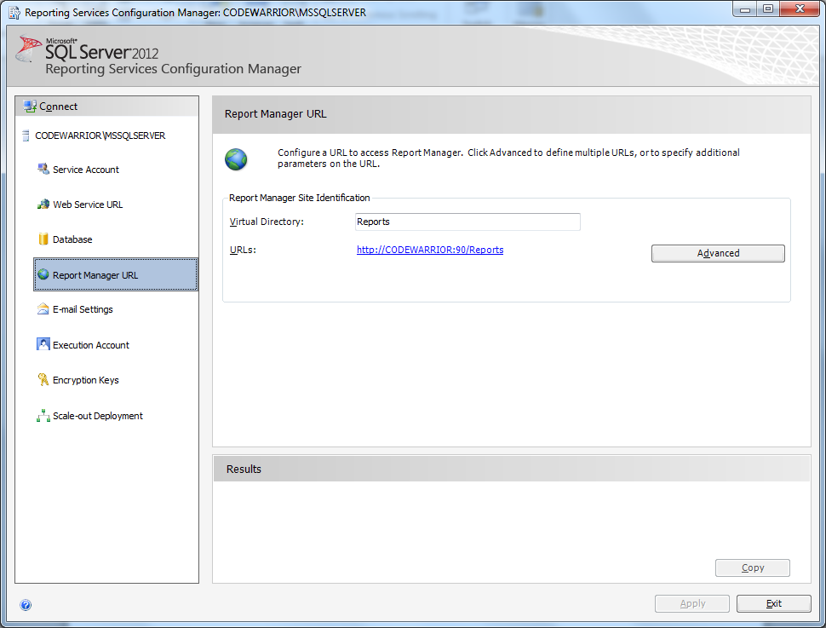

From this screen you are able to define the virtual directory for the Reports Manager and test the URL. It is strongly recommended the Virtual directory name have no spaces in it. If spaces are needed for readability it is recommended to use the underscore character in place of each space. The default of Reports is recommended but not required.

If you need multiple HTTP or multiple SSL identities you should click the advanced button at this time. This will bring you to the Advanced Multiple Web Site Configuration screen.

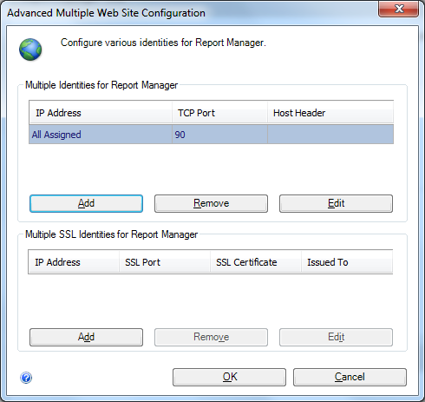

All the information that was entered on the previous screen (Report Manager URL) will be carried over to this screen. In each group box you are able to add the additional identities. When you are complete, click OK to save the changes, or Cancel to discard the changes.

To test the settings, click each link in the URL’s section. There should be a separate URL for each HTTP and SSL identity.

Click the Encryption Keys task, the Encryption Keys screen will be displayed.

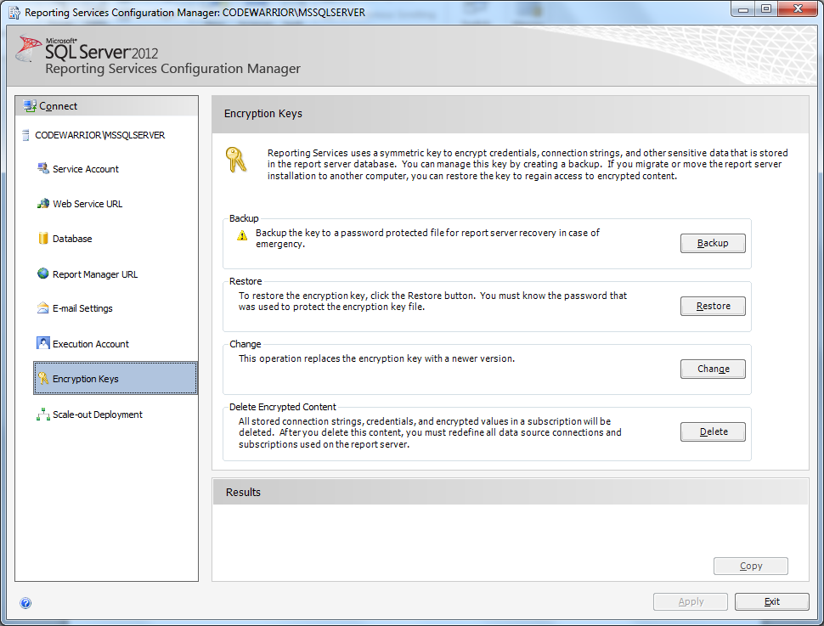

If this is a new installation, click the Delete button in the Delete Encrypted Content section. Once this is complete you will want to click the Service Account task to stop and restart the Reporting Services service.